Get profile flow

Flow diagram - IAM
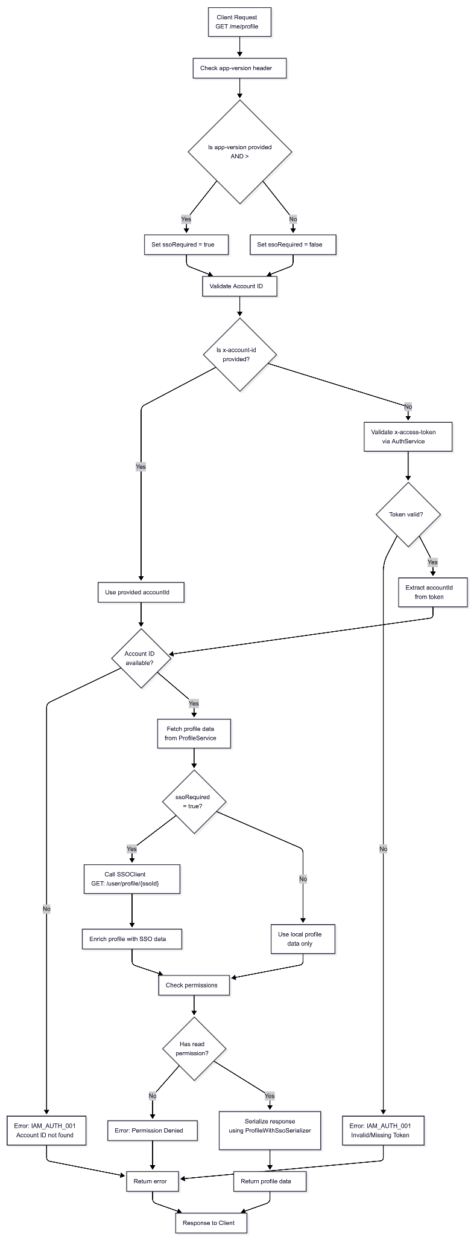

Flow diagram - SSO
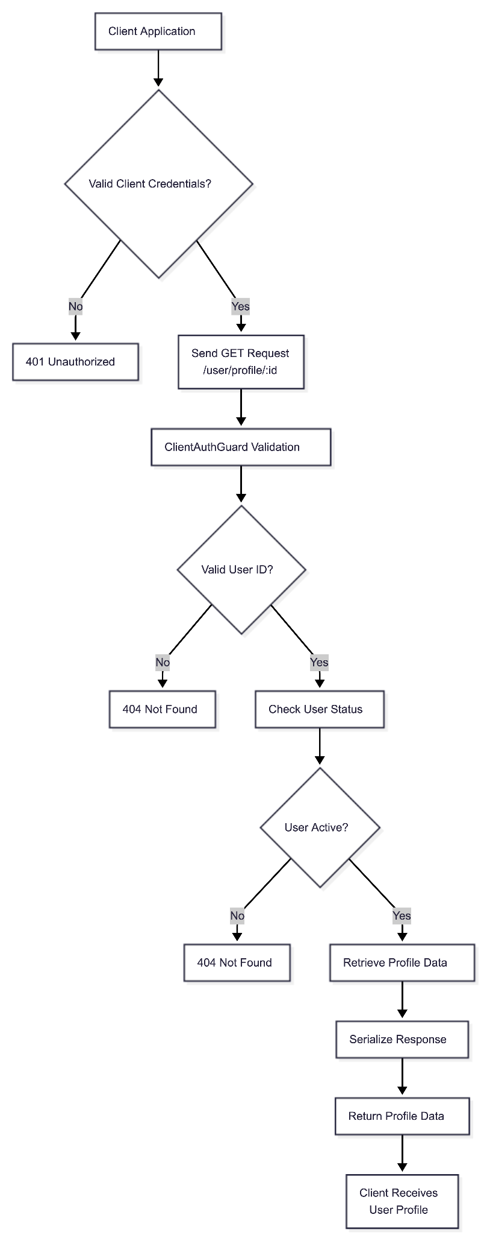

Preview Screen
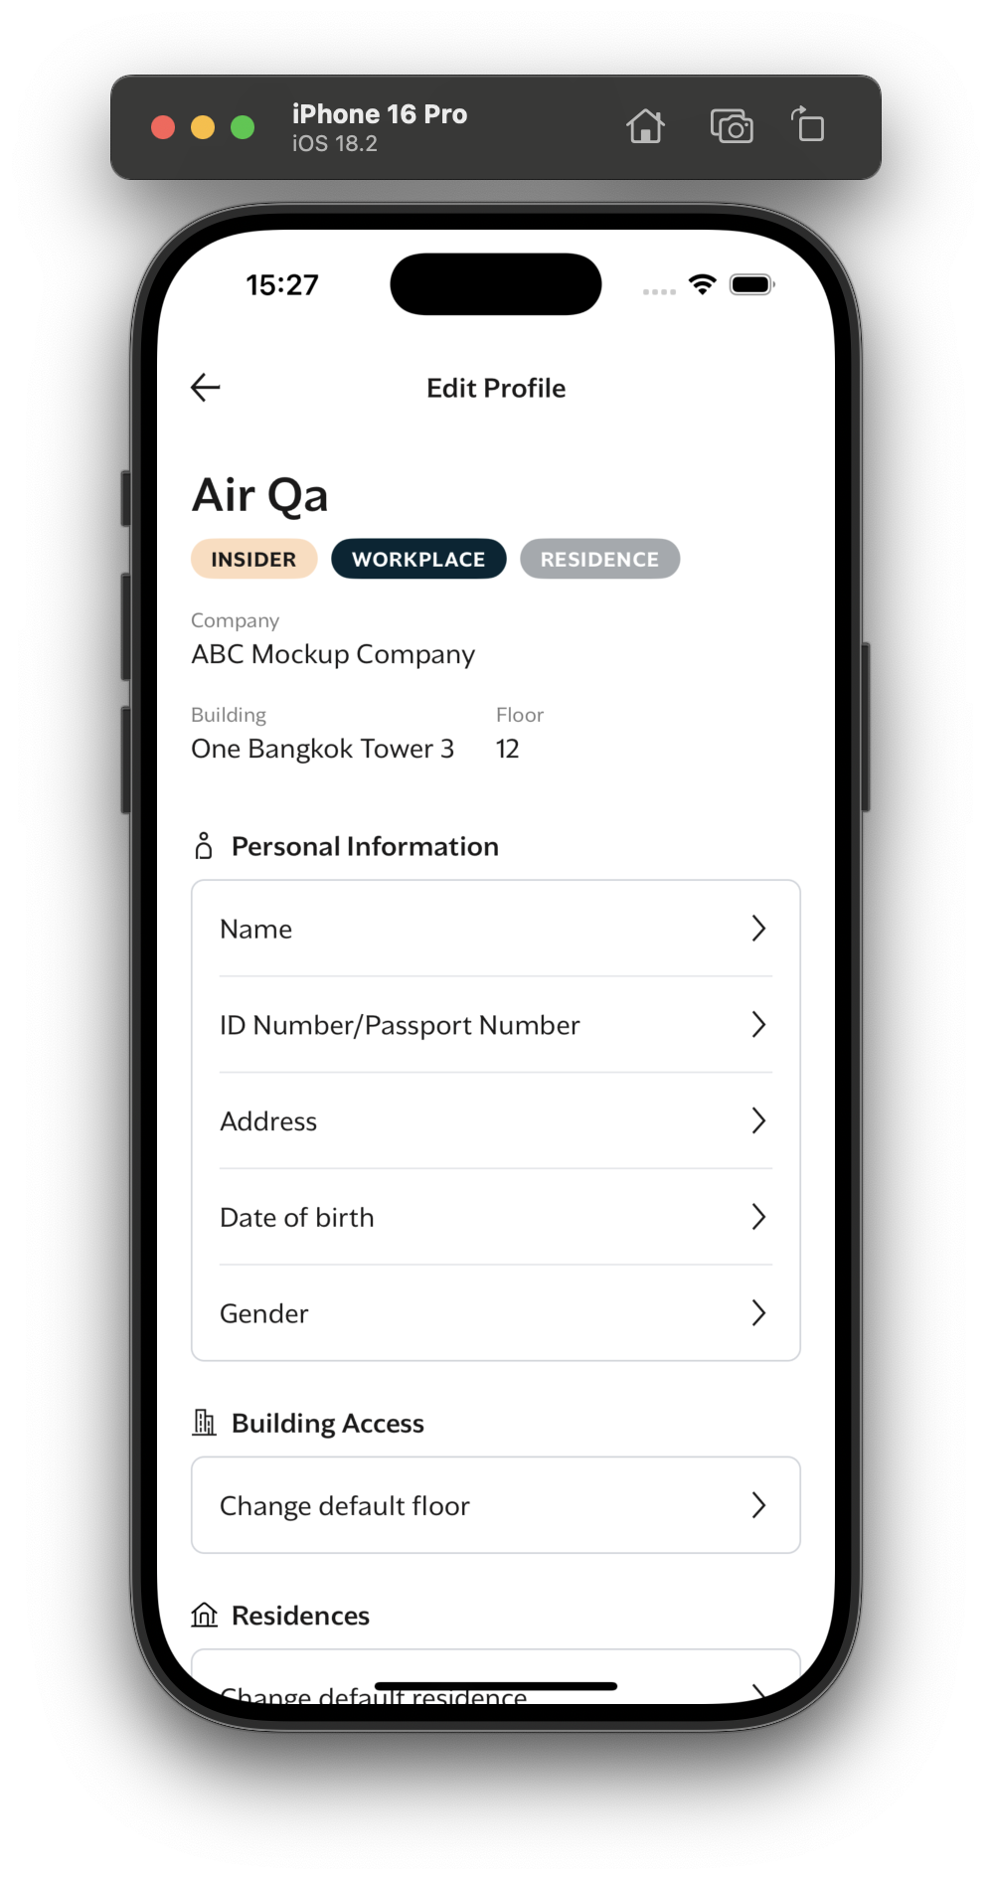

API Description - IAM

Description
Returns the authenticated user's profile and, when supported by the client version, enriches it with SSO profile data.

Request Structure

Header | Type | Required | Description
x-access-token | string | Conditional | JWT token for authentication. Required if x-account-id is not provided
x-account-id | string | Optional | Account ID of the user. If present, token validation is skipped
app-version | string | Optional | Client app version used to decide if SSO enrichment is required

Example request / response

Request - IAM get user profile

GET /me/profile HTTP/1.1
x-access-token: eyJhbGciOiJIUzI1NiIsInR5cCI6IkpXVCJ9...
x-account-id: 123e4567-e89b-12d3-a456-426614174000
app-version: 1.0.1

Response - IAM get user profile

{
"data": {
"profile": {
"first_name": "Qa",
"middle_name": "Fourty",
"last_name": "Nine",
"dob": "2025-08-28T00:00:00.000Z",
"title": null,
"gender": "male",
"created_at": "2025-12-17T13:38:57.881Z",
"deleted_at": null,
"sso_profile": {
"firstName": "Qa",
"middleName": "Fourty",
"lastName": "Nine",
"birthDate": "2025-08-28T00:00:00.000Z",
"profilePhoto": "",
"gender": "male",
"idCard": "123",
"passport": "",
"status": "active",
"publicId": "SSO_00822943636",
"createdAt": "2025-12-17T13:38:57.553Z",
"updatedAt": "2025-12-17T13:38:57.553Z",
"meta": {},
"addresses": [
{
"id": "9e0d0acc-1db8-4757-8948-c48d30e67abd",
"address": "",
"zipCode": "12000",
"province": "Pathum Thani",
"district": "",
"subDistrict": "",
"country": "",
"type": "home"
}
],
"emails": [
{
"id": "92c5c098-9cd9-4d8e-99d5-0033c8276194",
"value": "test0008@mtel.co.th",
"isDefault": true
}
],
"phoneNumbers": [],
"external": [
{
"id": "a7423f0b-a0cc-4af3-ba27-09d589596bfb",
"value": "3ba87b9b-cd52-4024-9464-4e6aff1b170c",
"provider": "iam"
}
],
"registrationType": "thai",
"hasPassword": true
},
"registration_type": null,
"persona": "user"
}
}
}

Error Scenarios
Error Code | HTTP Status | Condition | Notes
IAM_AUTH_001 | 401 | Missing or invalid x-access-token and no x-account-id | Authentication failed
IAM_PROF_001 | 404 | Profile not found for the resolved account | Local profile missing
IAM_SSO_003 | 500 | SSO call failed or missing sso_id when SSO is required | External SSO error
403 | 403 | User lacks permission to read the profile | Authorization failure

API Description - SSO

Description
Retrieves the profile information for a specific user by their publicId. This endpoint requires client authentication and returns detailed user profile data including personal information, contact details, and account status.

Request Structure - SSO

Parameters
Name | In | Type | Required | Description
id | path | string | Yes | The unique identifier of the user

Headers
Name | Type | Required | Description
clientId | string | Yes | Client identification key
clientSecret | string | Yes | Client secret for authentication

Request - SSO get user profile

GET /user/profile/{id}

Response - SSO get user profile

{
"firstName": "string",
"middleName": "string | null",
"lastName": "string",
"birthDate": "string | null (ISO 8601 format)",
"profilePhoto": "string | null",
"gender": "male | female | other | null",
"idCard": "string | null",
"passport": "string | null",
"status": "active | inactive | suspended",
"publicId": "string",
"createdAt": "string (ISO 8601 format)",
"updatedAt": "string (ISO 8601 format)",
"meta": "object",
"addresses": [
{
"id": "string | null",
"address": "string | null",
"zipCode": "string | null",
"province": "string | null",
"district": "string | null",
"subDistrict": "string | null",
"country": "string | null",
"type": "home | office | billing | shipping"
}
],
"emails": [
{
"id": "string",
"value": "string",
"isDefault": "boolean"
}
],
"phoneNumbers": [
{
"id": "string",
"value": "string",
"isDefault": "boolean"
}
],
"external": [
{
"id": "string",
"value": "string",
"provider": "facebook | google | apple | line",
"meta": "object (optional)"
}
],
"registrationType": "email | phone | facebook | google | apple | line | traveller | null",
"hasPassword": "boolean"
}

Error Scenarios
Status Code | Description
401 | Unauthorized - Invalid client credentials
404 | Not Found - User not found

